1. 
2. 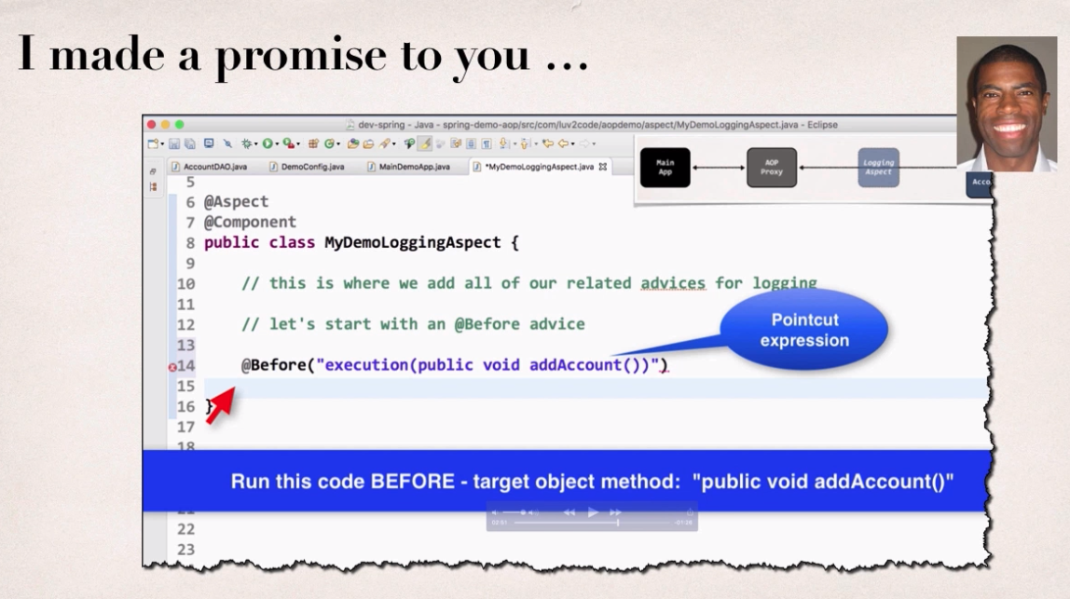
3. 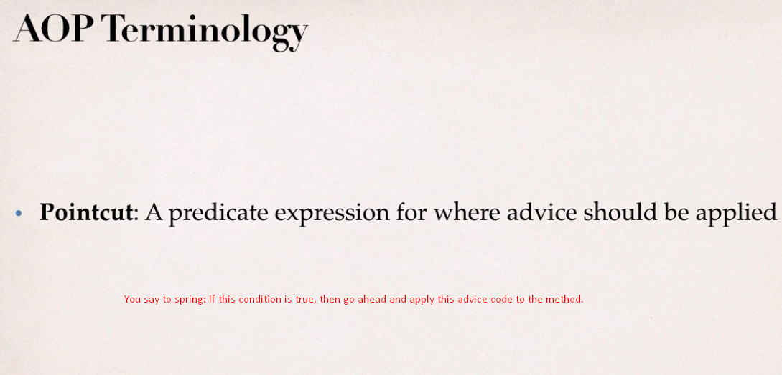
4. 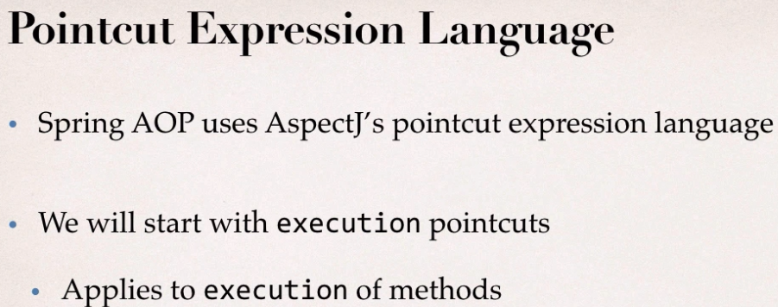
5. Pointcut expression language is used to define predicate to actually match on a given method and there are different patterns we can apply so let’s do ahead and break it down.
6. So this is **execution pointcut**: 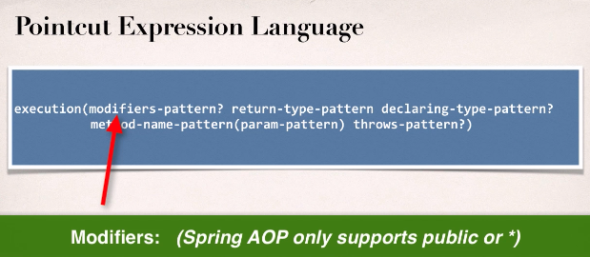
7. 